
Touchstones Project
Netcards

Theological Reflection Netcards with Text

Attitude HRJ
Autobiography HRJ
Awe HRJ
Black Cat HRJ

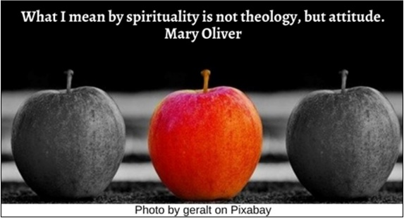



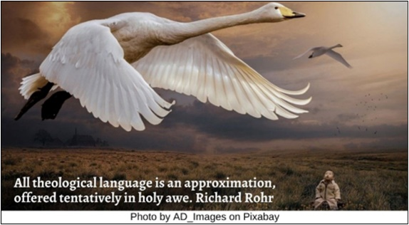

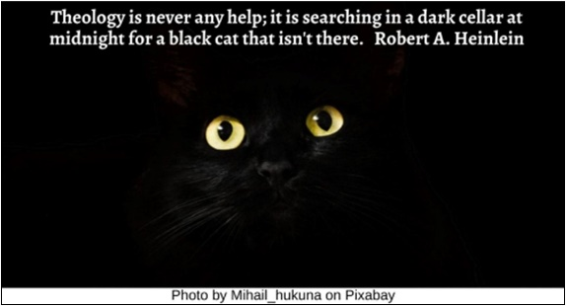

Books HRJ
Calm HRJ
Civilization HRJ
Clown HRJ



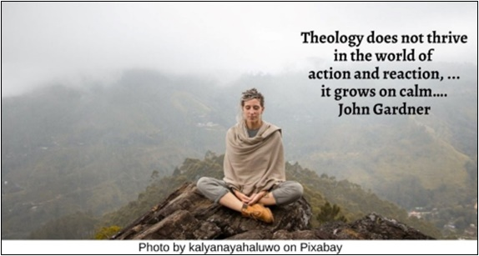



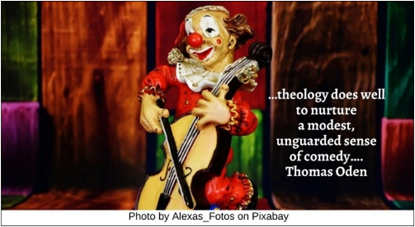

Dog HRJ
Heart HRJ
Heresy HRJ
Hungry HRJ





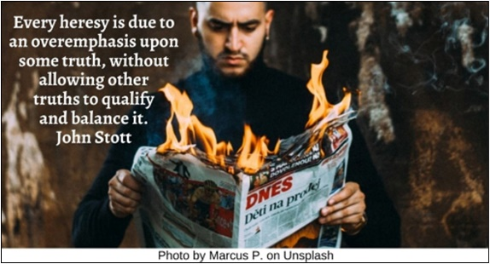

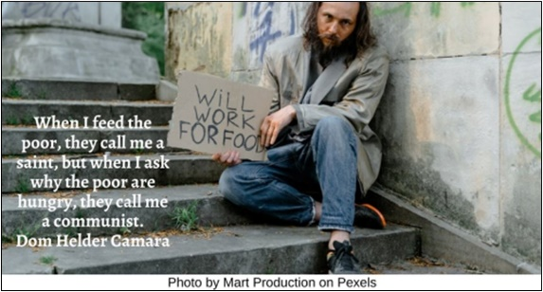

Hurting HRJ
Hymn HRJ
Laughing HRJ
Light HRJ

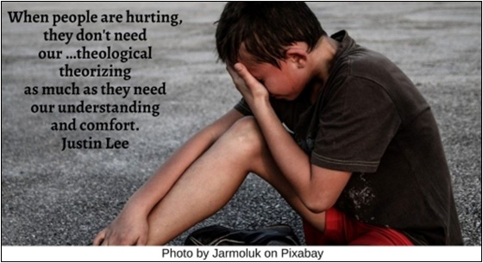

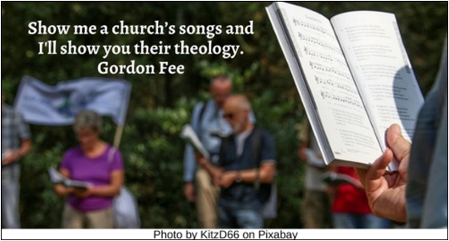

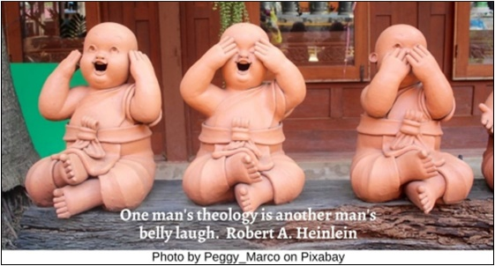

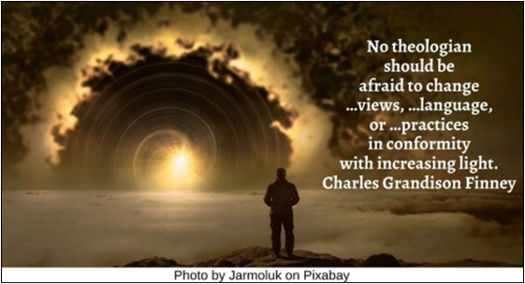

Logic HRJ
Manger HRJ
Mother Teresa HRJ
Mystery HRJ

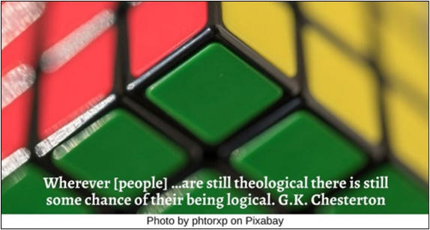

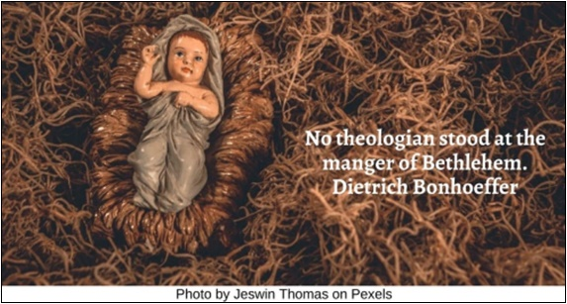

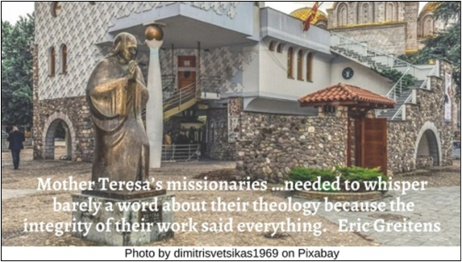

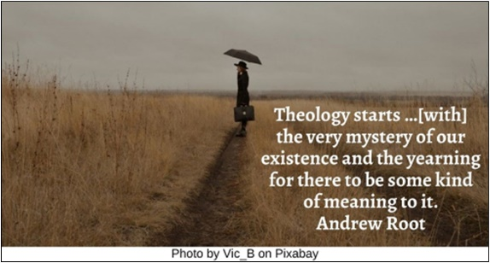

Old Map HRJ
Orchestra HRJ
Pain HRJ
Philosophy HRJ

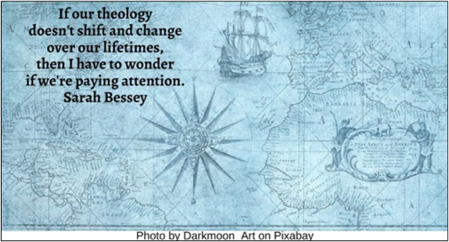

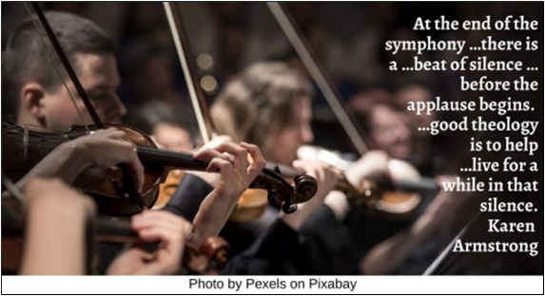



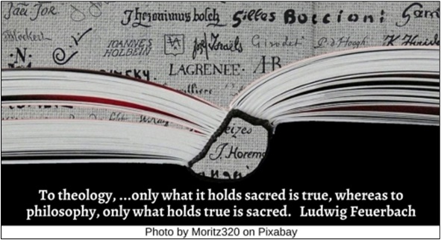

Poetry HRJ
Red Queen HRJ
Straw HRJ
Study HRJ



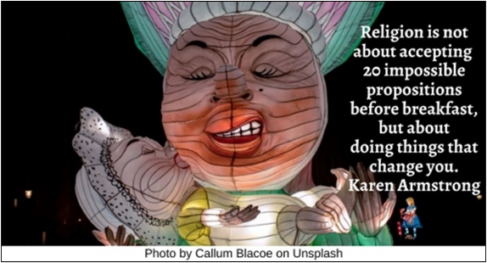

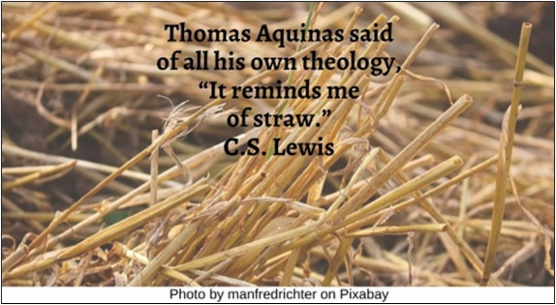



Suffering HRJ
Words HRJ
Wrong HRJ

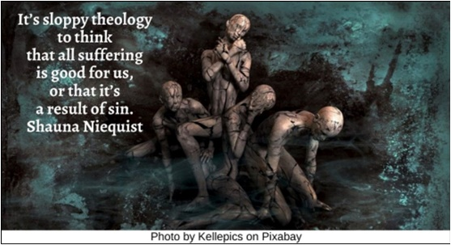

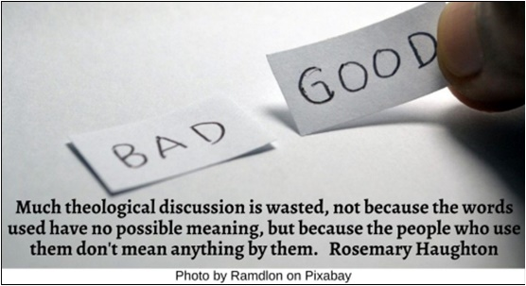

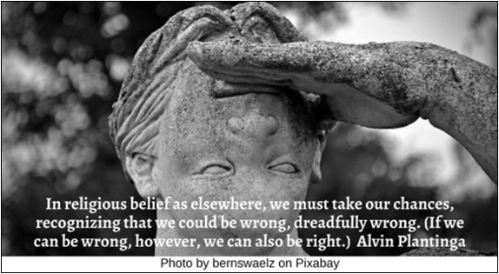

Text of Quotes
Attitude HRJ
What I mean by spirituality is not theology, but attitude. Mary Oliver

Autobiography HRJ
Theology, like fiction, is largely autobiographical. Frederick Buechner

Awe HRJ
All theological language is an approximation, offered tentatively in holy awe. Richard Rohr

Black Cat HRJ
Theology is never any help; it is searching in a dark cellar at midnight for a black cat that isn't there. Robert A. Heinlein

Books HRJ
I think my degrees in Theology and Psychology qualified me for nothing, but probably prepared me for everything. Brooke Bida

Calm HRJ
Theology does not thrive in the world of action and reaction, …: it grows on calm…. John Gardner

Civilization HRJ
Theological reflection takes place within history, but the history within which it takes place is an ongoing, open-ended process. David Novak

Clown HRJ
…theology does well to nurture a modest, unguarded sense of comedy…. Thomas Oden

Dog HRJ
A dog is grateful for what is, which I am finding to be the soundest kind of wisdom and very good theology. Carrie Newcomer

Heart HRJ
When we downshift …education from the paradigm of expertise to a paradigm of love, we do not dilute the importance of rigorous theological reflection. ...We learn best what we love most. Kenda Creasy Dean

Heresy HRJ
Every heresy is due to an overemphasis upon some truth, without allowing other truths to qualify and balance it. John Stott

Hungry HRJ
When I feed the poor, they call me a saint, but when I ask why the poor are hungry, they call me a communist. Dom Helder Camara

Hurting HRJ
When people are hurting, they don't need our …theological theorizing as much as they need our understanding and comfort. Justin Lee

Hymn HRJ
Show me a church’s songs and I'll show you their theology. Gordon D. Fee

Laughing HRJ
One man's theology is another man's belly laugh. Robert A. Heinlein

Light HRJ
No theologian should be afraid to change …views, …language, or …practices in conformity with increasing light. Charles Grandison Finney

Logic HRJ
Wherever [people] …are still theological there is still some chance of their being logical. G.K. Chesterton

Manger HRJ
No theologian stood at the manger of Bethlehem. Dietrich Bonhoeffer
Mother Teresa HRJ
Mother Teresa’s missionaries …needed to whisper barely a word about their theology because the integrity of their work said everything. Eric Greitens

Mystery HRJ
Theology starts …[with] the very mystery of our existence and the yearning for there to be some kind of meaning to it. Andrew Root

Old Map HRJ
If our theology doesn't shift and change over our lifetimes, then I have to wonder if we're paying attention. Sarah Bessey

Orchestra HRJ
…at the end of the symphony …there is a …beat of silence …before the applause begins. …good theology is to help …live for a while in that silence. Karen Armstrong

Pain HRJ
There is no simple theological answer to pain…. Henry Cloud

Philosophy HRJ
To theology, ... only what it holds sacred is true, whereas to philosophy, only what holds true is sacred. Ludwig Feuerbach

Poetry HRJ
Theology is—or should be—a species of poetry…. Karen Armstrong

Red Queen HRJ
Religion is not about accepting twenty impossible propositions before breakfast, but about doing things that change you. Karen Armstrong

Straw HRJ
Thomas Aquinas said of all his own theology, “It reminds me of straw.” C.S. Lewis
Study HRJ
To its critics, the study of theology distracts from real life. But, at its best, theology inspires and informs…. Alister McGrath

Suffering HRJ
It’s sloppy theology to think that all suffering is good for us, or that it’s a result of sin. Shauna Niequist

Words HRJ
...much theological discussion is wasted, not because the words used have no possible meaning, but because the people who use them don't mean anything by them. Rosemary Haughton

Wrong HRJ
In religious belief as elsewhere, we must take our chances, recognizing that we could be wrong, dreadfully wrong. (If we can be wrong, however, we can also be right.) Alvin Plantinga

